**HGTV + Valspar Alexa/paintbot Prototype Script**

**Introduction**

**USER: Alexa, ask Paintbot**

ALEXA: Welcome to Paintbot. Picking a paint depends on the painter. So, let’s start with a few questions.

>>Background image for welcome message needed

example:

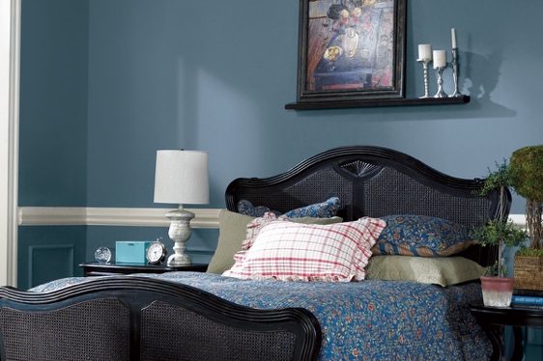

**Questions**

ALEXA: When you’re about to start a project, do you jump right in, or would you rather hide under the bed?

USER: Jump right in.

ALEXA: Okay, and do you have a good idea of what you want your room to look like? Say Yes or no?

USER: Yes.

ALEXA: Got it. And do you want your home to feel more bold and unique or calm and coordinated?

>> two images needed – 1. Room with bold and unique. 2. A room with calm and coordinated.

 for example

USER: Bold and unique.

ALEXA: Good choice. Last question for you. Take a look at the screen — which of these homes puts the biggest smile on your face?

IMAGE CAROUSEL ON SHOW SCREEN: 498x280 each

* HOME 1: Valspar A
* HOME 2: HGTV A
* HOME 3: Valspar B
* HOME 4: HGTV B
* HOME 5: Valspar C
* HOME 6: HGTV C
* HOME 7: Valspar D
* HOME 8: HGTV D

USER: Home 1 (Or selects HOME 1 on screen)

**Result**

ALEXA: Nice! Okay, based on your answers, it looks like you’re a real Rebel with a Roller. You don’t follow trends, you make your own.

ALEXA: That means Valspar is the right paint for you.

Alexa: Would you like to see some of our color palettes for inspiration?

User: Yes.

**Inspiration**

ALEXA: Here, check out some of these bold color palettes from Valspar.

Alexa : Please choose one.

IMAGE CAROUSEL ON SHOW SCREEN: 498x280 each

* VALSPAR VIBRANT REDS
* VALSPAR TROPICAL ORANGES
* VALSPAR SUNNY YELLOWS
* VALSPAR BRIGHT GREENS
* VALSPAR OCEANIC BLUES

(USER SELECTS WHIPPED STRAWBERRY FROM VIBRANT REDS PALETTE)

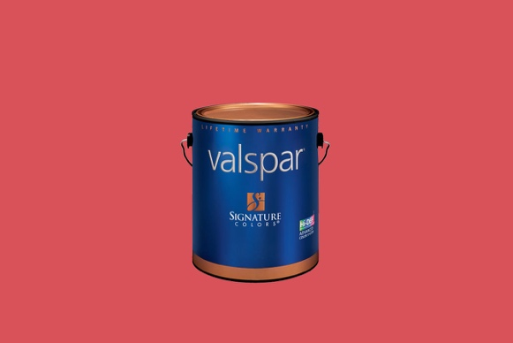

User: Whipped Strawberry.

ALEXA: Whipped Strawberry. Sounds delicious. Would you like to buy this paint?

USER: Yes.

**Drive to Store/Coupon:**

ALEXA: Great. You can find it at Lowes. Here’s the one closest to you.

(ON SCREEN PULLS UP MAP OF LOWE’S LOCATION AT 2630 N. NARRAGANSET AVE, CHICAGO, IL 60639 )

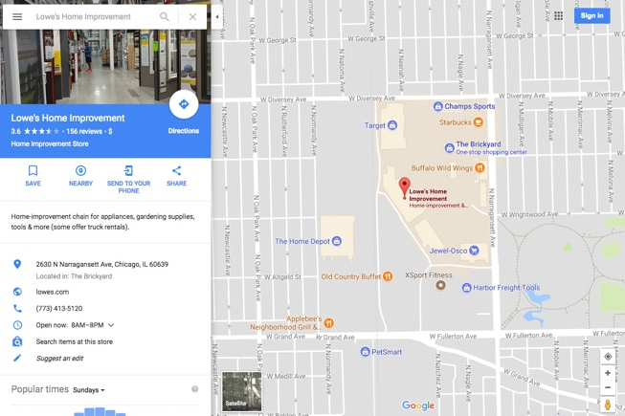

ALEXA: I’ll text you the address. Would you like a coupon too?

USER: Yes

**Closing**

ALEXA: Okay. When you get to Lowe’s you’ll find the Valspar paint in aisle fourteen.

ALEXA: Now go out there and get painting.

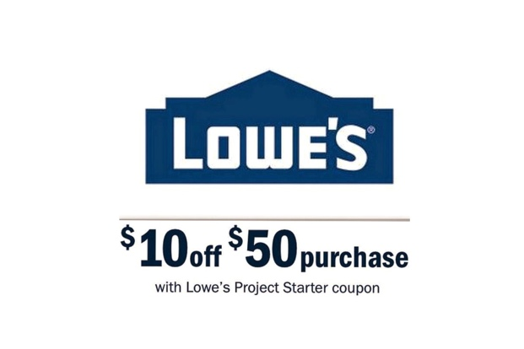

>> neither Coupon Image or paint cans image or ending screen image.